Long and Short Term Effects of Exercise Revision Guide

Mr Webb
St Mary’s Catholic Academy
GCSE Physical Education

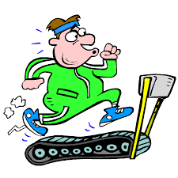

When a person takes part in exercise the cardiovascular, respiratory, energy and muscular systems all work together to supply energy to the working muscles and removes waste products.
Short Term Effects of Exercise

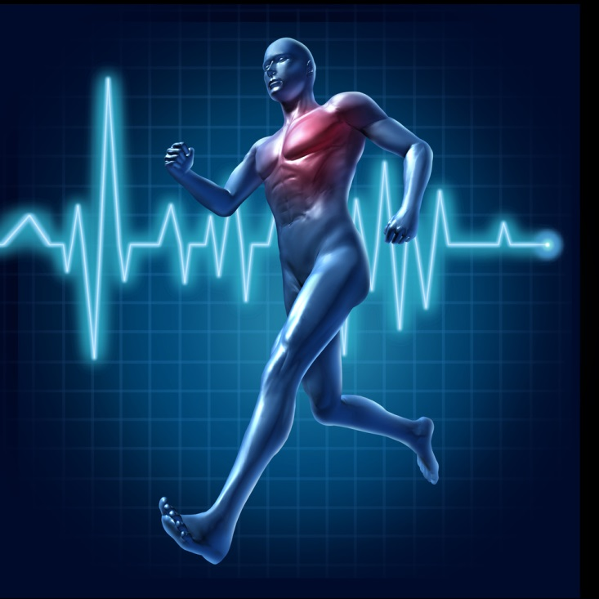
When the muscles start to work, they need more oxygen so the respiratory system responds by getting more oxygen into the lungs.
The blood carries greater amounts of oxygen and the heart responds to pump more oxygenated blood around the body.
Immediate effects can be visible in hot, sweaty and red skin.

 | Short term effects of exercise
Cardiovascular system | Increase in stroke volume (SV); increase in heart rate (HR); increase in cardiac output (Q); increase in blood pressure (BP)
Respiratory system | Increase in breathing rate; increase in tidal volume
Cardio-respiratory system removal | Increase in oxygen uptake; increase in carbon dioxide
Energy system | Increase in lactate production
Muscular system | Increase in temperature of muscles; increased pliability
Short Term Effects of Exercise
Light-headedness can be experienced in the hours after training and is usually a sign of either dehydration or low energy stores or both.
Tiredness and fatigue can be experienced in the days after heavy training or a big competition. This can be both physical but also mental tiredness. Sleeping well after training is therefore very important and can be thought of as part of an excellent recovery.

Short term effects of exercise (24 – 36 hours after)

Delayed Onset of Muscle Soreness (DOMS) occurs when muscles experience pain for 24-48 hours after intense exercise due to microscopic tears in the muscle fibers. DOMS typically follows a change in training or performance intensity and the muscles need to be rested while in this condition to avoid injury.

Nausea is a feeling of sickness that can take place during the hours and even days after very intense physical exercise. Athletes need to try to refuel even if they feel a little sick.

Taking part in regular exercise or training around three times per week for six weeks will lead to adaptation of the body systems that are used or trained. This has the effect of increasing performance in that type of exercise or sport and is often beneficial to general health and everyday life.
Long Term Effects of Exercise

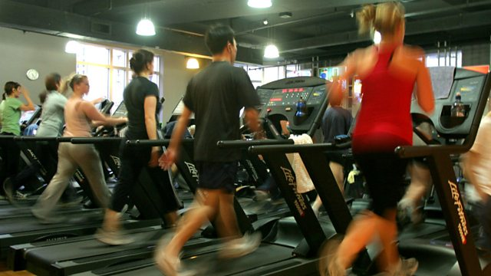
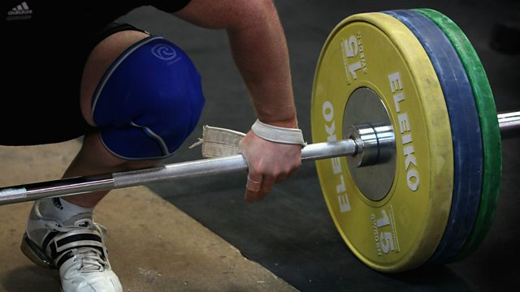

Resistance training increases strength
Aerobic training increases aerobic endurance

 | Long Term Effects Of Exercise | Type of Training
Cardiovascular System | Cardiac hypertrophy; increased stroke volume (SV); decrease in resting heart rate (HR); increase in maximum cardiac output (Q); capillarisation at the lungs and muscles; increase in number of red blood cells. | Aerobic
Respiratory System | Increased number of functioning alveoli; increased strength of the respiratory muscles (intercostals and diaphragm). | Aerobic
Energy System | Increased production of energy from the aerobic energy system; increased tolerance to lactic acid. | Aerobic/Anaerobic
Skeletal System | Increase in bone density. | Resistance
Muscular System | Muscle hypertrophy; increased strength of tendons; increased strength of ligaments. | Resistance
Fitness | Increase in strength; increase in flexibility; increase in speed; increase in muscular endurance. | Resistance; Stretching; Interval
Cardiac Hypertrophy & Capillarisation

Hypertrophy means an increase in size, so muscle hypertrophy means the muscles get bigger. If you weight train regularly doing biceps curls, your biceps will show muscle hypertrophy. Cardiac hypertrophy is where the ventricle wall gets larger or thickens as a result of exercise.

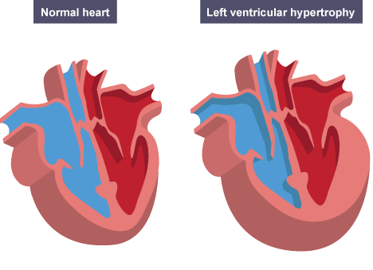
The muscle wall of the left ventricle increases in size, meaning it is able to pump out more blood during each contraction which increases the stroke volume. As stroke volume is increased, resting heart rate decreases but cardiac output (Q) remains the same as SV × HR = Q.

Capillarisation is the process where new capillaries are formed. Capillarisation takes place at the alveoli in the lungs and at the skeletal muscle. This has the effect of increasing the amount of oxygen that can be transferred to the working muscles as well as increasing the amount of carbon dioxide that can be removed.
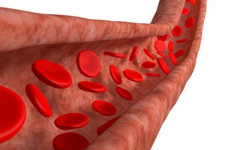

Which of the following is a short term response of the respiratory system to completing a training run?
- Increase in stroke volume
- Increase in lactate production
- Increase in tidal volume
Quick Questions

What typically happens to muscles temperature during a warm up?
- Remains constant
- Increase
- Decreases

Which term describes the increase in size of the heart wall as a result of long term training?
- Capillarisation
- Cardiac Hypertrophy
- Cardiac output

As a result of long term aerobic training, which type of blood cell would increase in number?
- White
- Platelets
- Red

Which process describes the growth of blood vessels around the lung and muscle caused by long term training?
- Hypertrophy
- Capillarisation
- Tolerance

Which muscle gets stronger as a result of training and increases the efficiency of the respiratory system?
- Diaphragm
- Biceps
- Triceps

Which part of the heart thickens the most as a result of cardiac hypertrophy?
- Atrial walls
- Right ventricle
- Left ventricle

Which of the following adaptations to training is an effect on the skeletal system?
- Increased vital capacity
- Increase in red blood cells
- Increased bone density

Which of the following is an anaerobic effect of long term training?
- Increase tolerance to lactic acid
- Increased number of functioning alveoli
- Decrease in resting blood pressure

After exercise has been completed, what should be done to ensure that the muscles adapt?
- Complete more training of the same kind
- Rest
- Complete a different training

- Increase in Tidal Volume
- Increases
- Cardiac Hypertrophy
- Red
- Capillarisation
- Diaphragm
- Left Ventricular
- Increased bone density
- Increased tolerance to lactic acid
- Rest
Answers

