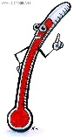

**COMPONENTS OF A WARM-UP:**

(There are 5 components you need to identify & give examples)

1.

2.

3.

4.

5.

**PRINCIPLES OF TRAINING:**

**Define each and give example;**

* **Specificity:**
* **Overload:**
* **Progression:**
* **Reversibility:**

**BENEFITS OF WARM-UP:**

(Identify the body changes and explain what happens)



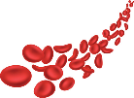

[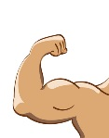](http://www.google.co.uk/url?sa=i&rct=j&q=&esrc=s&source=images&cd=&cad=rja&uact=8&ved=0ahUKEwjsu_D-0vHRAhVDtBoKHeJ8A2IQjRwIBw&url=http://www.clipartkid.com/cartoon-muscle-arm-cliparts/&bvm=bv.146073913,d.ZGg&psig=AFQjCNGEAH-qNAN8Lbb9m1TAxEs3To7JfA&ust=1486132942408475)

**Blood**

**BENEFITS OF COOL-DOWN:**

(Identify the body changes and explain what happens)

**1.2.b. APPLYING THE**

**PRINCIPLES OF TRAINING**



**OPTIMISING TRAINING:**

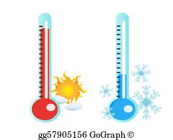

* **Methods of Training** (you need to identify & 3 explain 7):

1.

2.

3.

4.

5.

6.

7.

* FITT (define each):

F

I

T

T





