

**PHYSICAL:**

(Identify 8 physical factors and how they benefit physical activity and the consequence of a sedentary lifestyle)

**DEFINITIONS:**

HEALTH:

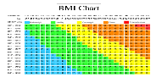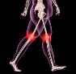

FITNESS:

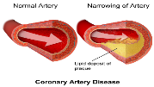

WELL-BEING:

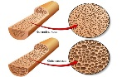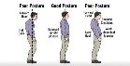

**2.3 HEALTH, FITNESS**

**& WELL-BEING**

**EMOTIONAL:**

(Identify 3 physical factors and how they benefit physical activity and the consequence of a sedentary lifestyle)

**SOCIAL:**

(Identify 3 physical factors and how they benefit physical activity and the consequence of a sedentary lifestyle)







