[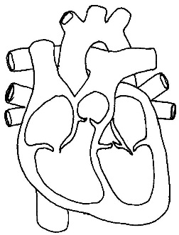](http://www.google.co.uk/url?sa=i&rct=j&q=&esrc=s&source=images&cd=&cad=rja&uact=8&ved=0ahUKEwj-u66vwNPUAhXHvBoKHQBoCkgQjRwIBw&url=http://cliparts.co/heart-diagram-unlabeled&psig=AFQjCNE3mElzqiaU5lIF4bnFP2o6yCjSyg&ust=1498291345813760)

**Name three long term effects on the cardiovascular system:**



**Name three short term effects on the cardiovascular system:**



**LONG TERM EFFECTS ON THE BODY SYSTEMS**

**SHORT TERM EFFECTS ON THE BODY SYSTEMS**

[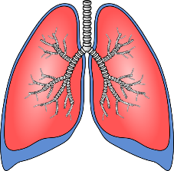](https://www.google.co.uk/url?sa=i&rct=j&q=&esrc=s&source=images&cd=&cad=rja&uact=8&ved=0ahUKEwiFn4j6wdPUAhXHlxoKHVOUAyEQjRwIBw&url=https://www.clker.com/clipart-lungs-1.html&psig=AFQjCNErfGvPiAfaY2XMuVfdrWISPdXvbg&ust=1498291765622413)

**Name three long term effects on the respiratory system:**



[](https://www.google.co.uk/url?sa=i&rct=j&q=&esrc=s&source=images&cd=&cad=rja&uact=8&ved=0ahUKEwiFn4j6wdPUAhXHlxoKHVOUAyEQjRwIBw&url=https://www.clker.com/clipart-lungs-1.html&psig=AFQjCNErfGvPiAfaY2XMuVfdrWISPdXvbg&ust=1498291765622413)

**Name three short term effects on the respiratory system:**



**1.1.e Effects of Exercise on the body**

**Name three long term effects on the**

**Muscular system:**



[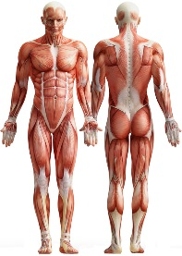](http://www.google.co.uk/url?sa=i&rct=j&q=&esrc=s&source=images&cd=&cad=rja&uact=8&ved=0ahUKEwiaxKCyxNPUAhWE7RQKHUjACVwQjRwIBw&url=http://www.fitnessuncovered.co.uk/muscles&psig=AFQjCNEVfQhMzWp0cSWNoCnE6XDz-RZ38w&ust=1498292417348692)

**Name three short term effects on the muscular system:**



[](http://www.google.co.uk/url?sa=i&rct=j&q=&esrc=s&source=images&cd=&cad=rja&uact=8&ved=0ahUKEwiaxKCyxNPUAhWE7RQKHUjACVwQjRwIBw&url=http://www.fitnessuncovered.co.uk/muscles&psig=AFQjCNEVfQhMzWp0cSWNoCnE6XDz-RZ38w&ust=1498292417348692)

[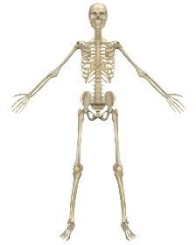](http://www.google.co.uk/url?sa=i&rct=j&q=&esrc=s&source=images&cd=&cad=rja&uact=8&ved=0ahUKEwjG1tTHxNPUAhXIOhQKHZ2fAigQjRwIBw&url=http://unsworth-primary.co.uk/what-is-the-purpose-of-a-skeleton/&psig=AFQjCNGV7PP44TKEptLJsh8PRQcJV2kKaw&ust=1498292471824603)

**Name three long term effects on the skeletal system:**



**Name three short term effects on the skeletal system:**



[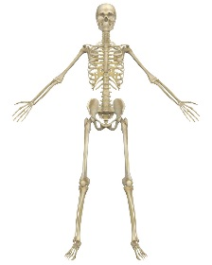](http://www.google.co.uk/url?sa=i&rct=j&q=&esrc=s&source=images&cd=&cad=rja&uact=8&ved=0ahUKEwjG1tTHxNPUAhXIOhQKHZ2fAigQjRwIBw&url=http://unsworth-primary.co.uk/what-is-the-purpose-of-a-skeleton/&psig=AFQjCNGV7PP44TKEptLJsh8PRQcJV2kKaw&ust=1498292471824603)