[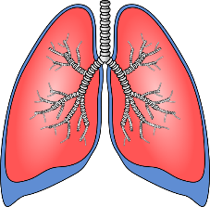](https://www.google.co.uk/url?sa=i&rct=j&q=&esrc=s&source=images&cd=&cad=rja&uact=8&ved=0ahUKEwiFn4j6wdPUAhXHlxoKHVOUAyEQjRwIBw&url=https://www.clker.com/clipart-lungs-1.html&psig=AFQjCNErfGvPiAfaY2XMuVfdrWISPdXvbg&ust=1498291765622413)

**Explain gaseous exchange:**

**Label diagram:**

**Structure & Function of the Respiratory System**

**Explain double-circulatory system:**

**Label diagram:**

**Structure & Function of the Cardiovascular System**

[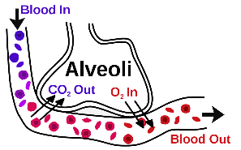](http://www.google.co.uk/url?sa=i&rct=j&q=&esrc=s&source=images&cd=&cad=rja&uact=8&ved=0ahUKEwi71YK9wtPUAhXFshQKHc6-CHsQjRwIBw&url=http://biology4alevel.blogspot.com/2015/03/52-summary-of-gas-exchange.html&psig=AFQjCNHsZH7VO1crau7nKTLIaw3TVNjkhw&ust=1498291913264741)[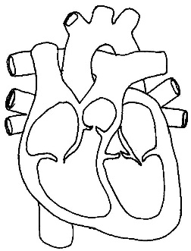](http://www.google.co.uk/url?sa=i&rct=j&q=&esrc=s&source=images&cd=&cad=rja&uact=8&ved=0ahUKEwj-u66vwNPUAhXHvBoKHQBoCkgQjRwIBw&url=http://cliparts.co/heart-diagram-unlabeled&psig=AFQjCNE3mElzqiaU5lIF4bnFP2o6yCjSyg&ust=1498291345813760)[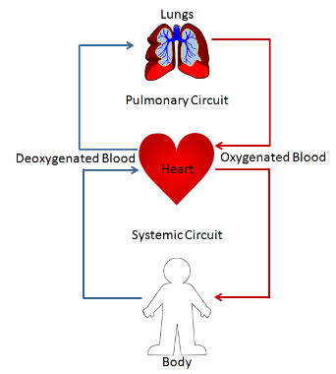](http://www.google.co.uk/url?sa=i&rct=j&q=&esrc=s&source=images&cd=&cad=rja&uact=8&ved=0ahUKEwi0uP3BwNPUAhXIShQKHQ1DBIoQjRwIBw&url=http://study.com/academy/lesson/double-circulation-definition-advantage-quiz.html&psig=AFQjCNHa22zfU_kPy5wE-UXna6-UaxBbAA&ust=1498291383480878)

**Explain:**

[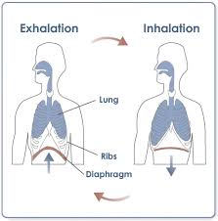](http://www.google.co.uk/url?sa=i&rct=j&q=&esrc=s&source=images&cd=&cad=rja&uact=8&ved=0ahUKEwiW9dvowtPUAhWB6xQKHcezCqMQjRwIBw&url=http://aventalearning.com/content168staging/2007BiologyB/unit9/section9_3.html&psig=AFQjCNE2t2BVreFWOhgBM8dOIROThcjynA&ust=1498291980808146)

**1.1.d Cardiovascular & Respiratory System**

**DEFINITIONS:**

1. **Breathing Rate:**
2. **Tidal Volume:**
3. **Minute Ventilation:**

* ARTERIES:

**AEROBIC & ANAEROBIC RESPIRATION:**

* CAPILLARIES:
* AEROBIC:

(Explain + sporting example)

* VEINS:
* ANAEROBIC:

(Explain + sporting example)

**DEFINITIONS:**

1. **Heart Rate:**
2. **Stroke Volume:**
3. **Cardiac Output:**