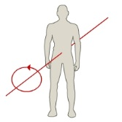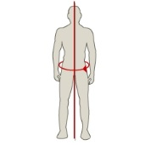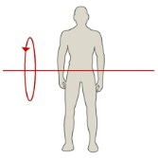

**PLANES OF MOVEMENT & AXES OF ROTATION**

(Label diagrams & give sporting examples)

**LEVER SYSTEMS**

What is mechanical advantage?

**1ST CLASS =**

(Draw a diagram showing effort, fulcrum. Load + give sporting example)

**2ND CLASS =**

(Draw a diagram showing effort, fulcrum. Load + give sporting example)

**3RD CLASS =**

(Draw a diagram showing effort, fulcrum. Load + give sporting

example)

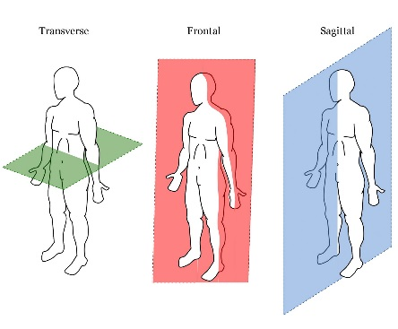

**LOCATION OF MUSCLES**

**11 MUSCLES IN TOTAL**

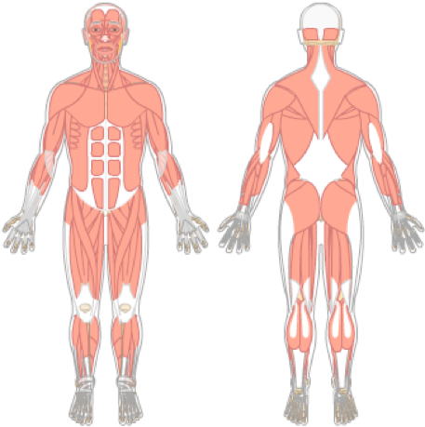

**1.1.b Muscular System**

**1.1.c Movement Analysis**

**ROLES OF MUSCLE IN MOVEMENT:**

* AGONIST:

[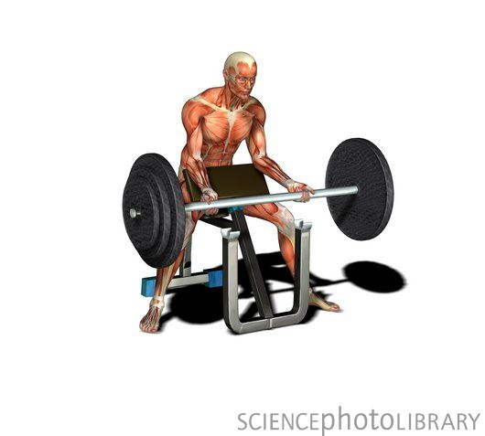](//www.sciencephoto.com/image/113639/large/C0049429-Male_muscles,_artwork-SPL.jpg)

* ANTAGONIST:
* FIXATOR: