Complete this work sheet with a partner.

1) Fill in the Gaps
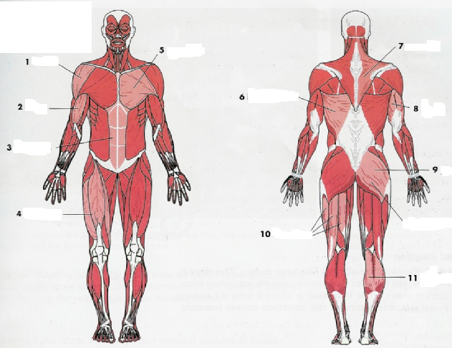

2) Complete the table

Number | Muscle | Main Action
1 | Deltoid | Raises your arm sideways at the shoulder.

