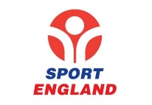

**PHYSICAL ACTIVITY & SPORT IN THE UK - Initiatives:**

Strategies to improve participation:

(There are 3)



**PARTICIPATION IN PHYSICAL ACTIVITY & SPORT…..CONTINUED:**

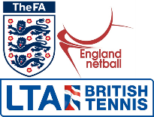

**2.1.a Engagement patterns in sport**

**PARTICIPATION IN PHYSICAL ACTIVITY & SPORT:**

(State both Positive & Negative factors)

MEDIA COVERAGE:

AGE:

FAMILY:

ENVIRONMENT:

GENDER:

EDUCATION:

OPPORTUNITY / ACCESS:

ETHNICITY:

DISABILITY:

ROLE MODELS:

RELIGION / CULTURE: